*Front page details:*



**Department of Computer Science and Engineering**

**B.M.S. COLLEGE OF ENGINEERING**

**Project Synopsis**

**On**

**TITLE: COGNITIVE SOMETHING**

**Submitted by:**

|  |  |  |  |
| --- | --- | --- | --- |
| USN | Names | Contact Numbers | Email Id |
| 1BM12CS082 | Prerna Bajaj | 9538984482 | [Prerna93lyka@gmail.com](mailto:Prerna93lyka@gmail.com) |
| 1BM12CS088 | Raksha Desai | 7259614879 | [Desairaksha93@gmail.com](mailto:Desairaksha93@gmail.com) |
| 1BM12CS079 | Pronoy Dalal | 9980950745 | [Pronoy.pro@gmail.com](mailto:Pronoy.pro@gmail.com) |
| 1BM12CS138 | Vardaan Tyagi | 9980225156 | [Vardaan.tyagi@gmail.com](mailto:Vardaan.tyagi@gmail.com) |

**Under the** **Guidance of :** Mr. Lohith J.J.

**INRODUCTION**

Jewelry has been an integral and almost essential part of all cultures—prehistoric to contemporary period. Jewelry with special powers is also part of folklore and mythology. That the modern technology can indeed endow jewelry with special abilities is the premise for this project.  
Today with advances in affordable miniaturization technologies and societal acceptance of wearable technical gadgets, it is possible to make jewelry that can incorporate sensors, actuators, and wireless communication chips to enhance human experience in daily lives. This is known as Cognitive Jewelry.

While you probably feel safe at home with your security system, that feeling of protection may not extend far from your front door. This wearable device has a technology that can help offer you that sense of security no matter where you are. This device is being formulated for the society, especially for the safety of women, which is a major concern in today’s life. The device is used to provide flexibility and choices for the wearer

**OBJECTIVE**

* To design a robust wearable product that works through gesture recognition, which can be implemented in the field of security.

- To understand the basic working of ARM Cortex Mo+ microprocessor and explore it’s working with different gesture oriented devices

* To understand and explore the working of Accelerometer and implement gesture sensing.
* To understand the working to BLE (Bluetooth Low Energy) and integrate it with different devices to meet Product goals
* To help each other in the team and overcome all the difficulties faced during the generation of the product.

**REQUIREMENTS**

* HARDWARE REQUIREMENTS
* ARM Cortex MO+ (Nordic 51822)
* 3-Axis Accelerometer
* BLE(Bluetooth Low Energy)
* Handheld Device
* Batteries
* SOFTWARE REQUIREMENTS
* Keil C166 Development Tools
* 32 bit Operating System (Windows/MAC)
* Eclipse SDKs

**WORKPLAN**

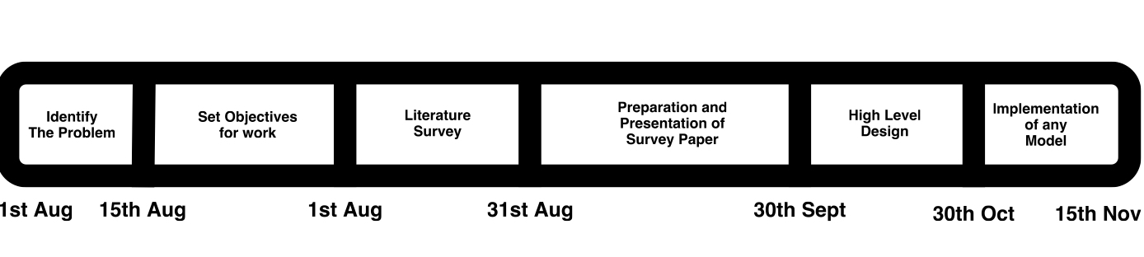

The "Calorie Count and Gesture Recognition Ring" employs a reflective pulse oximetry sensor, information from which is used to measure the movements by the user during the day while performing various activities. Based on this information the user can get advice about the predicted hazard on his smart phone. The ring also has a 3 axis analog accelerometer, which is used for gesture recognition as well as activity measurement. The ring is interfaced to a smartphone using Bluetooth 2.0.

The algorithm will be built for gesture recognition. The algorithm will be unique primarily because it uses a single accelerometer to recognize dynamic hand gestures. However, the use case requires jewelry to do real time computation as well as requires it to be a low power consumption device, so the algorithm will be optimized to be able to handle all the computation on the ring alone.

In an effort to reduce the size of the Product, the pulse oximetry sensor will be removed from the ring, and the analog accelerometer will be replaced with a digital one. The advantage of this approach is that some processing work could be offloaded to the built in processor of the digital accelerometer. Moreover this accelerometer will have built in tap, double tap and free fall detection. Further flexibility and smaller size will be achieved by using Texas Instruments’ Bluetooth Low Energy.

**CONCLUSION**

Our Device is an innovative security device that you don’t need to press or squeeze to activate. It has embedded sensors that can measure any amount of force applied to the wearer, which is meant to identify signs of physical assault and send out a call for help. Even if certain levels of impact are part of your day-to-day life, this wearable security device can tell when the situation is violent enough to warrant help alert. You can also connect it to your smart phone so as to identify your location using GPS.

In conclusion, it is very important you keep in mind that the best protection you can give yourself is to avoid potentially dangerous situations as much as possible. After all, it is often said that prevention is better than cure. So try as much as possible to avoid being a victim of crime, and a great way to achieve this is to have a high level of security awareness or consciousness.

**REFERENCES**

[www.artemisfashion.com](http://www.artemisfashion.com)

[www.safelet.com](http://www.safelet.com)

[www.amulyte.com](http://www.amulyte.com)

[www.dhruvsuxsena.com/cognitive-jewellery/](http://www.dhruvsuxsena.com/cognitive-jewellery/)